24101869
Music Marketing Plan
Budson – A brand, a business and a global mindset
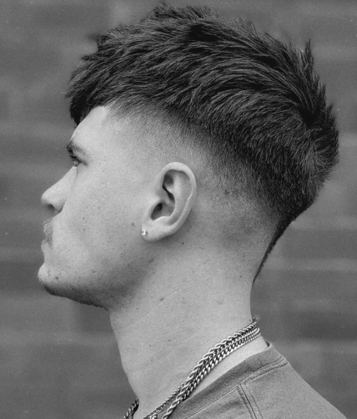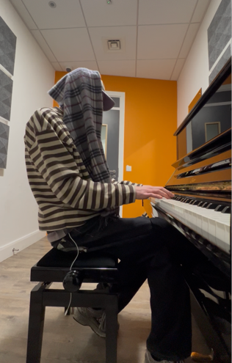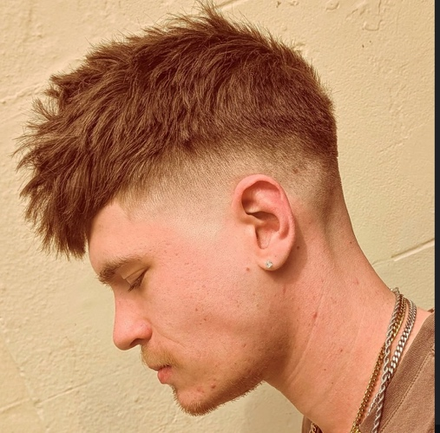
Executive Summary
This strategic marketing campaign plan outlines the development and promotion of Budson, an independent music artist and producer based in Leeds, UK. The campaign focuses on establishing Budson within underground Hip-Hop and electronic music markets through the release of a trilogy of interconnected albums: Jepter, Invincible, and Intheclouds.
The campaign primarily targets 18–30-year-old alternative music listeners active on platforms such as TikTok, Instagram, and SoundCloud. Through social media marketing, audience engagement, collaborations, and live performances, the campaign aims to increase brand recognition, streaming figures, and long-term audience loyalty.
The strategy also focuses on building relationships with media channels, playlist curators, underground music communities, and industry gatekeepers to expand the reach of the BYC collective and strengthen Budson’s position within the independent music industry.
Brand Overview
Within an oversaturated music market dominated by formulaic mainstream releases, Budson offers an alternative sound that combines Hip-Hop, dance music, ambient music, and electronic pop to create a distinctive musical identity.
Target Audience & STP Strategy
My campaign will target 18–30-year-old alternative music listeners active on platforms like Instagram, TikTok and SoundCloud. I selected this segment due to their high engagement with the underground music scene and digital artist communities.
This approach reflects the ideas of segmentation, targeting, and positioning within modern digital marketing strategies (Smart Insights, n.d.).x
Limitations of STP theory
Outliers. There will always be people who don’t fit into these specifics of what you would like them to do even when you have calculated that they should ‘theoretically’ do it.
You could do all the correct things with applying theories such as STP but still if you as an Artist are not appealing to the consumer of the advertisements then no results will come from it.
STP theory allows me to target my brand and its products and services to those who’re most likely to engage with it and become consumers. I think specifically with the current climate of the music industry and the tools that social media for example has to offer, STP theory Is very useful to discover your niche and the categories of people that would like what you offer.
The campaign also reflects aspects of Blue Ocean Strategy through its emphasis on differentiation and niche positioning (Kim and Mauborgne, 2015).
I aim to create a music brand image that pushes for a new recognition of sound; one based on musical fusion, the merging of genres and an understanding of music as purely an art form and expression of oneself.
I don’t abide myself to set rules within genres, I simply respect the roots and apply myself to genres in a way that is true to me and best reflects my musical abilities.
Despite my music having influences within it, I push a personal perspective on the world and write music, particularly lyrics in a way that is inherently different to the norm and typical standard ways, as an artistic choice.

Product focus
Invincible, Jepter, Intheclouds

I decided to centre this marketing plan around the release of three specific albums that are all musically interconnected and create a trilogy. With the focus on these albums, I will be reviewing potential streaming figures, social network recognitions, potential profit and other statistics that I would like to see because of the album releases.
FRI 5TH JUNE – RELEASE 1 JEPTER
FRI 4TH SEPTEMBER – RELEASE 2 INVINCIBLE
FRI 4TH DECEMBER – RELEASE 3
The promotion of these three albums will largely all follow a similar process.
Currently
My brand is already known, to some degree.
The main question I aim to work on continually every day, is how I grow that recognition, and following, and solidify it into something stronger and more defined. I believe starting small & aiming to get a small loyal base at first Is crucial, and I aim to do just that. In this portfolio, I will explain how I will develop my brand and my current level into something bigger, and more known.

Strategic Goals
At the level my brand is currently at, it is essential to have set goals that’re achievable. Each time a goal is hit, one can advance onto the next goal which can likely be something on a grander scale, due to the previous goal that was achieved. Without the process of development, brands can easily stagnate, and given my brand is centred around my career as an artist producer, that is highly susceptible.
Set Goals
- 2 Seasonal Albums every year
- 2 Beats sent to artists a week
- Steady growth of +5 followers a week
- 1000 Brand followers by 2027
- 1 Artist signed a year to BYC
- £50 generated from music by 2027
Given I make beats for myself and others to buy/ use, it is important for the brand to stay consistent with its quality and vision strength. A large way to do this is to release 2 solo albums every year, to imprint his mark in the HipHop/ EDM world and claim his market space without always sharing the song with another artist/ producer. I can creatively direct my projects and create a niche sound within the sectors of music I largely take inspiration from.
When compared to sending two beats to artists every week, if each of those beats were used, that would still be far more collaboration projects anyway. These further spread my sound into various music niches and helps push the vision further. Given a bigger aim of the brand is really to become global, and have a defined sound within a collective and a record label, other artists using my beats only helps the brand grow and likely increase in popularity

SWOT ANALYSIS
Strengths | Weaknesses
Distinct underground aesthetic and sound identity | Limited mainstream recognition
Multi-skilled artist (producer, DJ, collaborator, performer) | Smaller marketing budget/resources
Authentic independent branding appeals to niche audiences | Limited industry connections compared to signed artists
Strong creative control and originality | Audience reaches still developing
Collective/community aspect through BYC label | Potential inconsistency in content output

Opportunities | Threats
Growth of TikTok & algorithm-driven music discovery | Oversaturation of independent artists online
Rising demand for authentic underground music scenes | Difficult to maintain visibility due to platform algorithms
Playlist placements on SoundCloud | Rapidly changing music trends
Collaboration opportunities with underground creators | Competition from label-backed artists
Live events and local communities | Financial instability in independent music careers

Media + Promotion Strategy
- Highest performing promotion video = screen recording of one of my DAW sessions with a caption about bringing back 2000’s dance music.
- Really, I would attribute this to the return of nostalgia as a heavy force for peoples interests and tastes, lots of old music, films, fashion trends etc returning into everyday life and driving people’s decisions.
- A large proportion of this is likely also linked to the push back against rapid technological advancements, videos with lots of hardware and analogue equipment on social media getting lots of views and recognition.
- As a brand the best choice for me to make, in which I choose to do, is optimise on this and aim to create nostalgic feels within my music to capture attention of consumers.
Increased followers by 30 over a 2-month period compared to 30 in an entire year just through active posting. – consistency is everything when it comes to results.
Instagram and TikTok are two of the most important places for any young artist to spend their time, statistics show more than 600 million people go on Instagram every day, with an estimated 875 million to 1 billion on TikTok every day. The level of customer opportunity for a modern artist that comes because of those figures is certainly one not to be understated, with consistent posting opening more doors than ever, as I have discovered for myself.
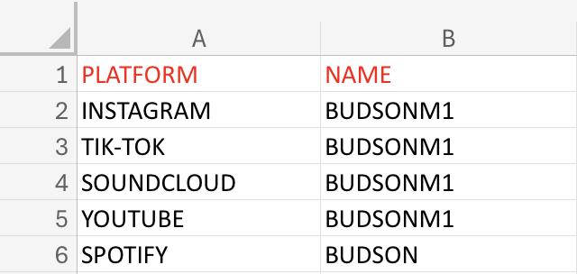

Demographics
Most common follower – Man from Sheffield aged between 18 + 24. Still stuck in the ‘local’ trap, need to spread wider.
Least common follower - Woman from a random nation across the globe aged over 65+.
Paid advertising generated limited audience conversion, suggesting that organic engagement strategies may currently be more effective for growth.
Networking + Industry Gatekeepers
- The rule of 7 (promoting music repeatedly until people hear your music 7 times and finally decide that they like what they hear)
- Consistent brand image
- Eye-catching, attention-grabbing content
- Consistent releases of music
- Emphasise USPs to develop a niche following

The campaign will aim to build relationships with industry gatekeepers including playlist curators, local event organisers, underground music promoters, and independent music blogs. These individuals and platforms play a key role in increasing visibility and credibility within the music industry.
Social media platforms mentioned will act as the campaign’s primary media channels due to their effectiveness in music discovery and audience engagement among younger consumers. Consistent posting, short-form video content, and collaboration with other underground artists will be used to strengthen audience reach and improve brand recognition.

Brand Identity
Free spirited persona of self-belief and enthusiasm with an emphasis of rebellion against elitist structures
‘Be You’
Genre + Sound
Ethereal & textured heavy drum focused electronic music
Influences
Often fusing artists such as Fred again, Mobb Deep, Kanye West, Theo Parrish, The Alchemist, Lee Scott, BYNX leading to new fusions within bigger styles of music.

Visual Identity
Dark colours, purples, blues, greys, browns
A lot of imagery of self-such as on covers etc to put a focus on how most of my music is entirely built from scratch with me as creative director
Blurred imagery and thought - provoking art on hip hop and dance covers

Core Message
My core message is simple; ‘I want people to create not consume; I want people to want to improve their life. and build connections with the everyday man, I want people to explore who they truly are through music expressionism’
The brand promotes individuality, self-expression, and creative independence
My message would most likely resonate with those who have already explored taking a journey into themselves on an introspective level, those who’re open to new ideas and that has consequentially led them to find me and resonate with the inner message’
Promotional Materials
- Digital content
- Posters
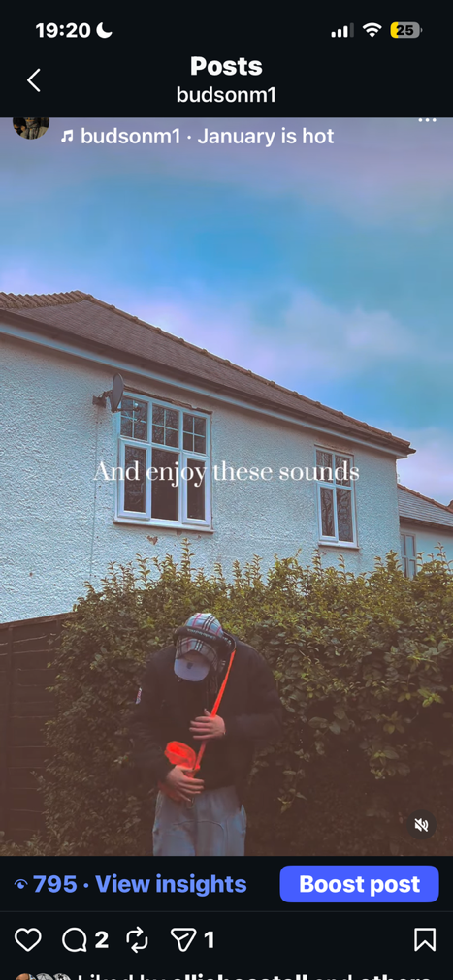
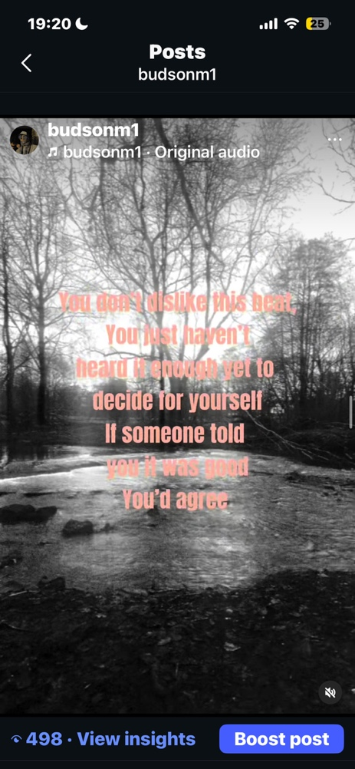
- Social Media posts
- Merchandise
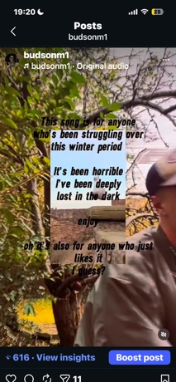
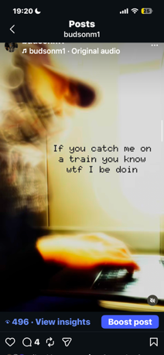
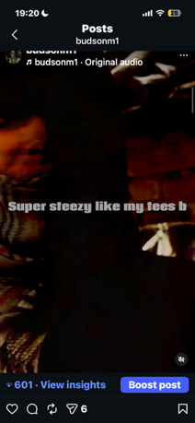

Gantt Chart & Timeline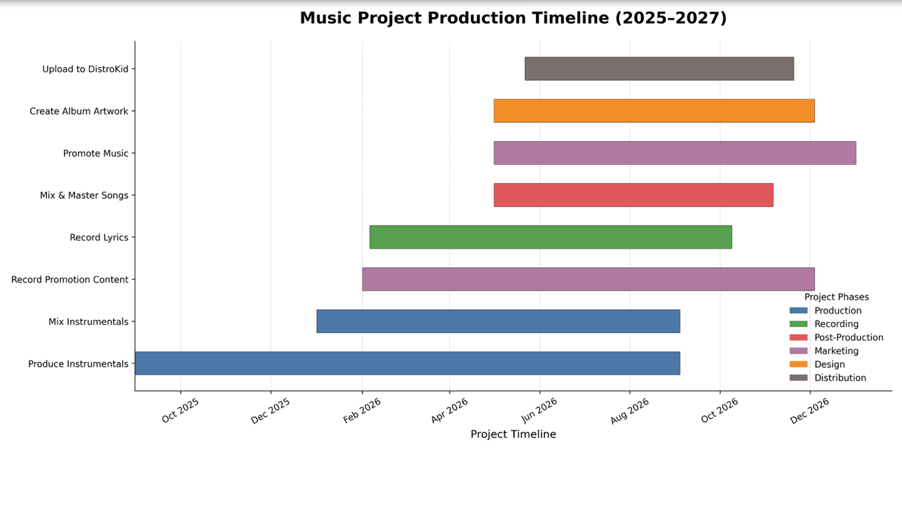
The chart
My Gantt chart, officially beginning in August 2025, shows the true length of time it takes to develop three early-stage music career albums. As shown, the most important element to the release of the album was the quality of the beats, given the type of music the albums are. The length of instrumental producing took roughly an extra 3 months of time. The quickest process of course being the distribution, uploading each album to distribution services roughly two weeks before date, using the benefits of my artist membership plan. With enough emphasis on dedicating myself to the release of these albums, I think each task certainly has enough time to be completed, with certain months more than others focused in particularly on only one.
Financial Forecast
Profit/loss forecast
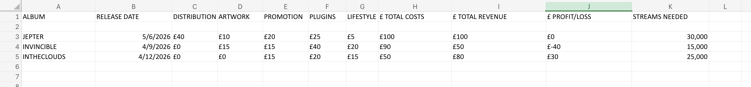

The chart above shows the five main sections of costs in a spreadsheet forecast amongst each album. The main takeaway from the chart is that in total between all three of the albums, there is only a £15 profit generated. Now as a small independent artist, I think this is still something despite being a very small amount of money. Another interesting point to notice is how my cheapest album, would be my most profitable album. However, that can also be put down to how the distribution costs only sit on one album as I am using a yearly Distrokid membership, hereby not having to spend more on distribution every time I release.
Conclusion
This strategic marketing plan demonstrates how ‘Budson’ can develop as an independent music brand through consistent branding, audience engagement, and digital promotion. The campaign is centred around increasing visibility within underground Hip-Hop and electronic music communities through the release of a trilogy of interconnected albums, supported by social media marketing, networking, and collaboration.
As an independent artist operating within an oversaturated music industry, establishing a recognisable identity and maintaining consistent audience engagement are essential for long-term growth. Through platforms such as TikTok, Instagram, and SoundCloud, the campaign aims to expand audience reach while strengthening the presence of both Budson and the Broke Youth Collective (BYC).
The current music industry requires artists to operate not only as musicians, but also as marketers, content creators, and brand managers. Therefore, balancing music production with promotion, networking, and audience interaction remains a central part of the campaign strategy. Although challenges such as limited resources, market saturation, and unpredictable audience behaviour remain there, the plan highlights realistic and achievable methods for independent brand development within the digital music scene.
Ultimately, the campaign is driven by a long-term vision of building a recognisable and authentic music brand that encourages creativity, individuality, and artistic expression while establishing a sustainable presence within the independent music industry.

References:
Adobe (n.d.) STP Marketing Model. Available at: https://business.adobe.com/uk/blog/basics/stp-marketing-model(Accessed: 2 April 2026).
Berger, J. (2013) Contagious: Why Things Catch On. New York: Simon & Schuster.
Berklee College of Music (n.d.) Music Marketing Strategies. Available at: https://www.berklee.edu/berklee-now/news/music-marketing-strategies (Accessed: 18 March 2026).
Blue Ocean Strategy (n.d.) Red Ocean vs Blue Ocean Strategy. Available at: https://www.blueoceanstrategy.com/tools/red-ocean-vs-blue-ocean-strategy/ (Accessed: 27 February 2026).
Blue Ocean Strategy (n.d.) Taylor Swift: Blue Ocean Strategist in the Entertainment Industry. Available at: https://www.blueoceanstrategy.com/blog/taylor-swift-blue-ocean-strategist-entertainment-industry/ (Accessed: 7 May 2026).
Business.adobe.com (n.d.) STP Marketing Model. Available at: https://business.adobe.com/uk/blog/basics/stp-marketing-model (Accessed: 11 March 2026).
Cascade (n.d.) Blue Ocean vs Red Ocean Strategy. Available at: https://www.cascade.app/blog/blue-ocean-vs-red-ocean-strategy (Accessed: 24 April 2026).
Cialdini, R.B. (2021) Influence: The Psychology of Persuasion. New and Expanded edn. New York: Harper Business.
Godin, S. (2018) This Is Marketing: You Can’t Be Seen Until You Learn to See. New York: Portfolio.
Kim, W.C. and Mauborgne, R. (2015) Blue Ocean Strategy: How to Create Uncontested Market Space and Make the Competition Irrelevant. Expanded edn. Boston: Harvard Business Review Press.
Musicians’ Union (n.d.) Marketing and Promotion. Available at: https://musiciansunion.org.uk/career-development/career-guides/marketing-and-promotion (Accessed: 30 March 2026).
Smart Insights (n.d.) Segmentation, Targeting and Positioning. Available at: https://www.smartinsights.com/digital-marketing-strategy/customer-segmentation-targeting/segmentation-targeting-and-positioning/ (Accessed: 9 April 2026).
Spotify (n.d.) Spotify for Artists. Available at: https://artists.spotify.com (Accessed: 14 February 2026).
The Strategy Institute (n.d.) Understanding the Red Ocean vs Blue Ocean Strategies. Available at: https://www.thestrategyinstitute.org/insights/understanding-the-red-ocean-vs-blue-ocean-strategies (Accessed: 5 May 2026).
TikTok (n.d.) TikTok for Artists. Available at: https://artists.tiktok.com (Accessed: 21 April 2026).

