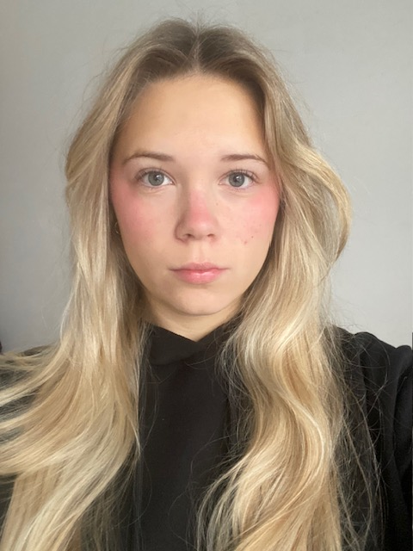
Details
Based: Liverpool, Leeds, London
Playing age: 14-21
Height: 5”2
Appearance: White, British
Eye colour: Green/Grey/Blue
Hair colour: Blonde
Hair length: Mid
Voice quality: Strong

Credits
Title | Date | Role | Company | Director
As You Like It | May/2023 | Rosalind | Lipa | Timothy Lynskey
Katzenmusik | May/2024 | Grace | Lipa | Jonnie Riordan
Rimmers Of Eldritch | December/2025 | Eva Jackson | Leeds Conservatiore | Jess Millward
Twelth Night | February 2026 | Viola | Leeds Conservatiore | Alex Palmer
Mary and The Hyenas | May 2026 | - | Leeds Conservatiore | Heather Caroll

Accents & Dialects
Native: Liverpool accent/ scouse
High standard: American-Standard, American Southern, Australian, Cockney, Geordie, RP, Scottish.
Languages Native: English
Music & Dance
Highly skilled: Ballet, Modern, Pointe
Skilled: Intermediate Ballet
Performance Physical Theatre, Musical Theatre, Singing (Alto/Soprano)
Sports Skilled: Tennis, cycling, running, netball, swimming

