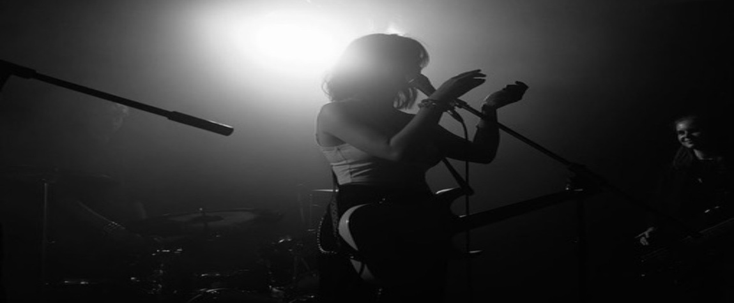

Grace Parker
\

About
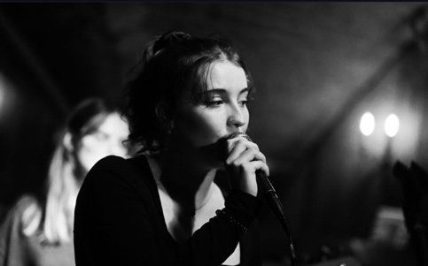
Grace is a dynamic musician based in the North, with skills in pop and rock vocals, guitar, songwriting and classical/pop piano. With a rich classical training of 10+ years, she manages to incorporate sound theoretical knowledge into all her endeavors. She is passionate about and actively takes part in events concerning women’s issues in music and is also a part of multiple ensembles. These include Mother Ryasa (an all-girl rock band in Leeds); Fondabath (a heavy rock, grunge band in Manchester) and a folk-rock duo with Noah Fenton.

Currently, studying a classical music degree (majoring in Piano), Grace is not bound by one genre and is a massive advocate for crossing boundaries within music. Her participation in the grunge-gaze band, Fondabath, is partial to the genre of ‘guitar music’ and powerful lyricism – contrasting with her soothing folk guitar duo and dreamy keys playing in Mother Ryasa. She is an introspective songwriter and aims to build on her solo output and presence in the future.

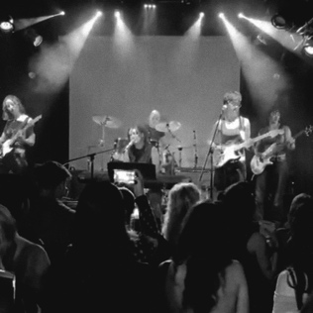
Summarise skills/experiences
Grace’s greatest achievements to date take a range of influences within the rock/alternative scene. She performed a sweeping headline at Club Academy in 2022 and has immersed herself in the Manchester alternative scene, forming relations with major venues like Oldham Street, Night and Day, Gulliver’s and Retro. She has released a 3 track EP under the band Fondabath, managing the songwriting and keys arrangement and she aims to keep releasing music under her various ensembles. Her online music presence also includes the release and direction of two music videos under Fondabath.

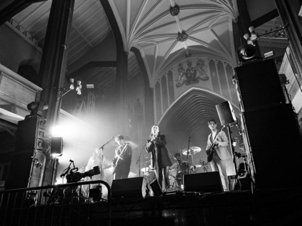
Grace is passionate about and has taken part of multiple charity festivals and events, including the Festival of Nature in Wilmslow, where the audience biked to create energy for the music equipment. She has also played Hebden Bridge’s Pride festival and is always organising new events. For instance, in September 2025 she hopes
to host a ‘Night of Joni Mitchell’ to raise money for female-based music charities. This will focus on women in classical, folk and jazz fields, opening a space for more women to thrive in these unlikely fields.
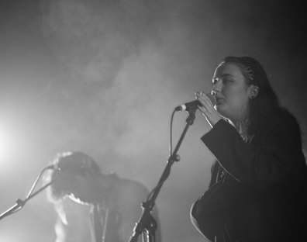
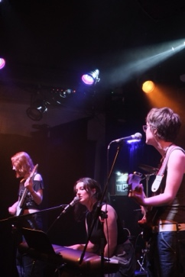

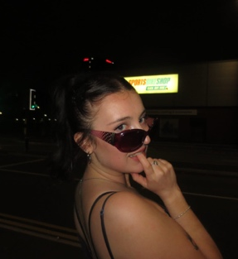

Reviews/testimonials
Grace’s main band, Fondabath, has received numerous reviews. It’s All Indie write that: ‘Instrumentally it's packed with huge guitar moments and tumbling guitars with the chorus being jam-packed with soaring riffs, much like how any decent guitar track should be.’ while Joyzine describe them as a ‘less frantic Scheer (if you know your 90’s Northern Irish alternative bands)’. Other reviews liken Grace’s sound in Fondabath to that of Wolf Alice, with her soft, yet piercing vocals battling the soaring and crunchy guitar.
They also write that Fondabath have ‘the hype behind them to take over the scene in the North West of England…’.
Social media links:
https://www.fondabath.com
https://open.spotify.com/artist/5HrfPRU6sjD59nH1jf9xM5
https://www.instagram.com/motherryasa/
https://www.instagram.com/fondabath/?hl=en
https://www.youtube.com/@fondabath
https://www.instagram.com/graceparkcr/
https://www.tiktok.com/@grace_e509
https://www.tiktok.com/@fondabath

Professional contact information:
g.i.parker@hotmail.com
motherryasa@gmail.com
fondabath@gmail.com
07470 388091

http://www.itsallindie.com/2022/08/fondabath-shares-crunching-debut-single.html
https://lessthan1000followers.com/2022/07/30/unknown-but-essentials-july-2022/
https://www.eventhestars.co.uk/2022/12/track-of-day-1-fondabath-craving.html#more
https://joyzine.org/2024/02/25/live-in-pictures-hello-cosmos-big-society-fondabath-at-st-marys-church-stockport/
https://www.live-manchester.co.uk/hello-cosmos-to-headline-at-stockport-st-marys-church/

Upcoming performances:
Mother Ryasa: 4th May: Charity gig at the Lending Room
Noah and Grace: 30th May: Headrow House

