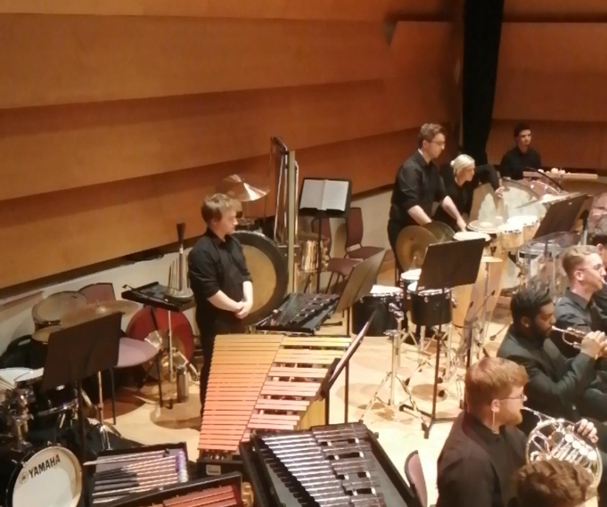
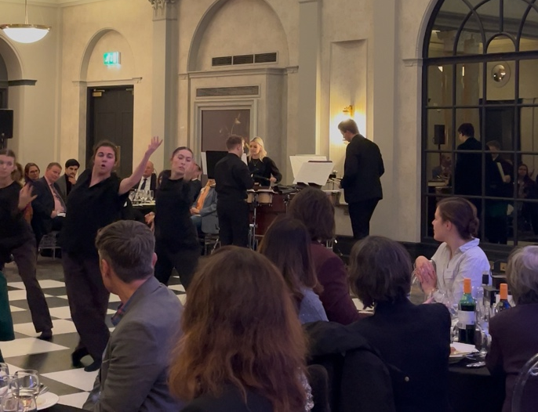
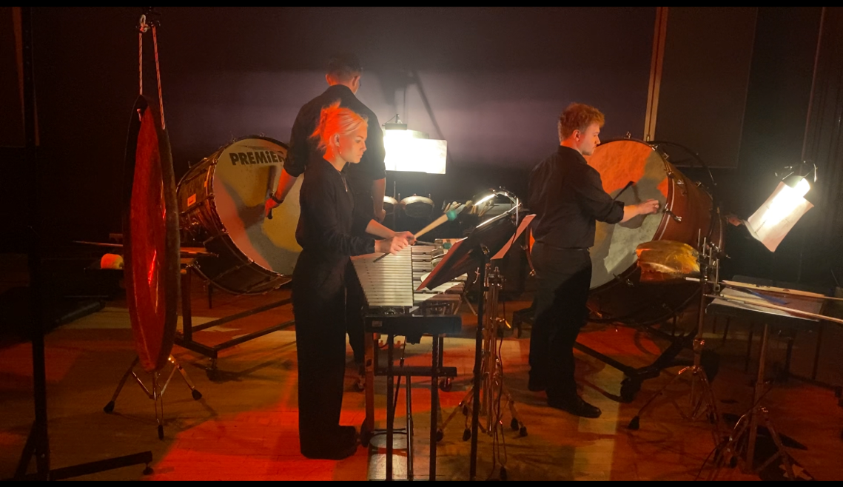
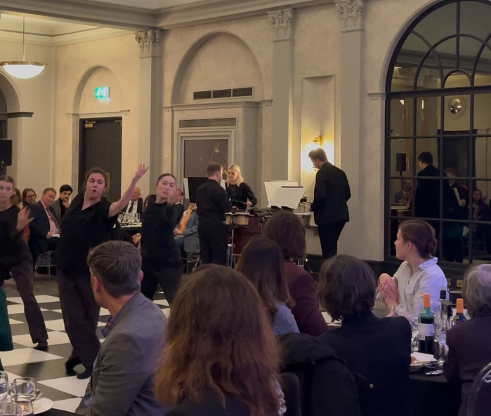
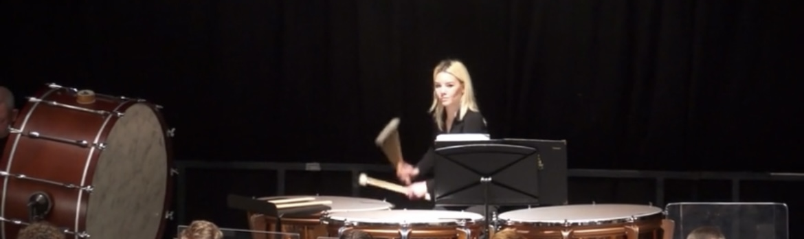
KEY HIGHLIGHTS
- Played with Kent Youth Wind Orchestra and Kent County Youth Orchestra

- Performed at Leeds Light Night with Percussion Trio

- Performed with members of Opera North Orchestra

- Performed at the annual Anglo- French Conference dinner, with her Percussion trio and performed with dancers from Northern School of Contemporary Dance and musicians from the Lille Conservatoire.

- Percussion section leader for Orchestra and Wind orchestra at Leeds Conservatoire

- Worked with established conductors throughout many orchestra projects such as: Natalia Luis-Bassa, Caroline Hobbs-smith, Helen Harrison, Karen Ní Bhroin
Link to portfolio:

https://drive.google.com/drive/folders/1jiJszc_qUpcKewQstIQhKmOKRw-PgVm5?usp=share_link

BIO
Nancy is a 20-year-old classical percussionist based in Leeds and Kent, studying at Leeds Conservatoire. Her musical journey has seen her quickly establish herself as a talented and versatile percussionist. After starting on drum kit, she progressed to percussion and at age 17 Nancy gained a place on the Kent Youth Wind Orchestra and the Kent County Youth Orchestra, performing in a wide range of orchestral settings.

At Leeds Conservatoire, Nancy started a percussion trio, which has performed in numerous recitals and events, showcasing her ability to collaborate and bring fresh interpretations to classical works. She also plays regularly in the conservatoire's orchestras, often collaborating with esteemed musicians, including members of the Opera North Orchestra. Additionally, Nancy has gained valuable experience by depping for amateur orchestras throughout West Yorkshire, as well as playing with the Opera North
Youth Orchestra, further expanding her performance repertoire.

Driven by a passion for orchestral music, Nancy is eager to gain more experience in professional orchestral settings while also pursuing teaching opportunities. Her ambition to inspire others is matched by her commitment to perfecting her skills.
:
Email: nancyjoynerr@yahoo.com
Instagram: nancyjoyner_percussion

Nancy Joyner
Percussion

